A report OR a demo on how to set up a project moderator/lead position from the instructor-side

Creating your project repository

Following instructions can be found at

https://docs.github.com/en/get-started/quickstart/create-a-repo

Access github webpage at

https://github.com/

on the upper right corner of the home screen click Sign In



In the following page enter your login and password.

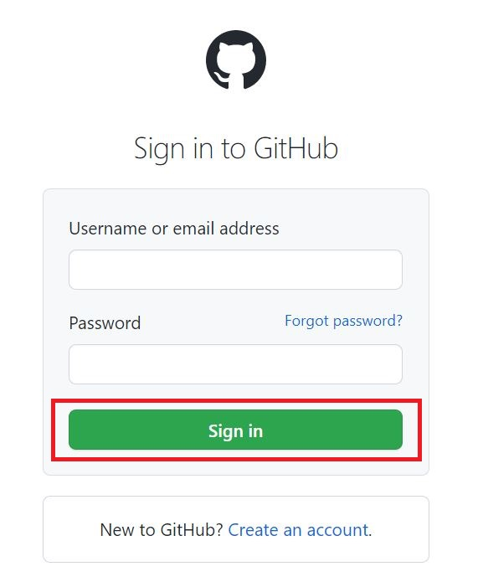
Click Sign in

In the following page click Create repository

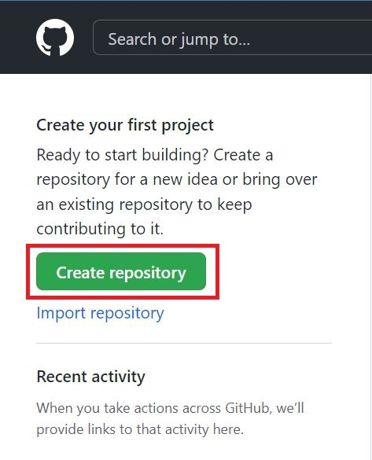
Select Owner (current login) and enter name for your repository.
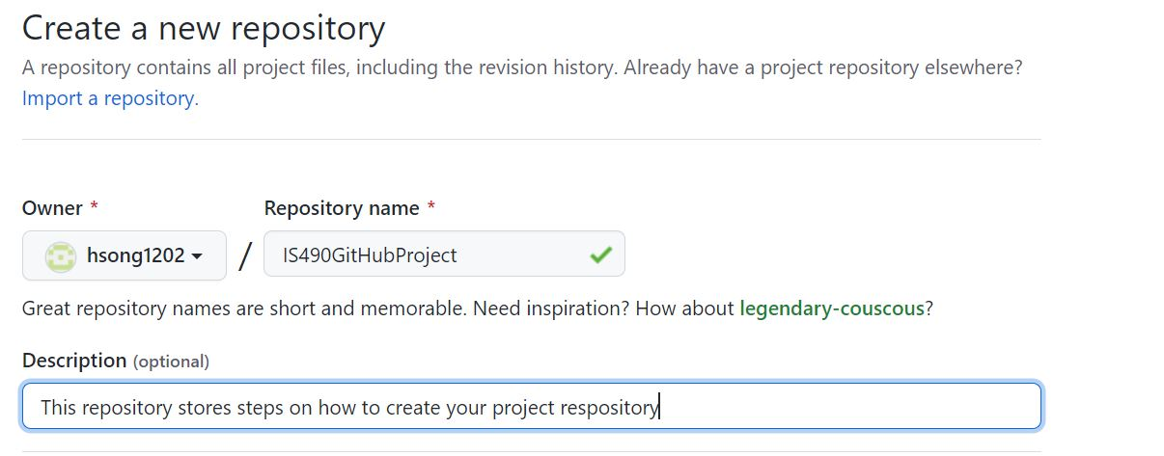
Below the Description field there are options to make the repository public or private, in order for students to Fork your repository it has to be set to public.
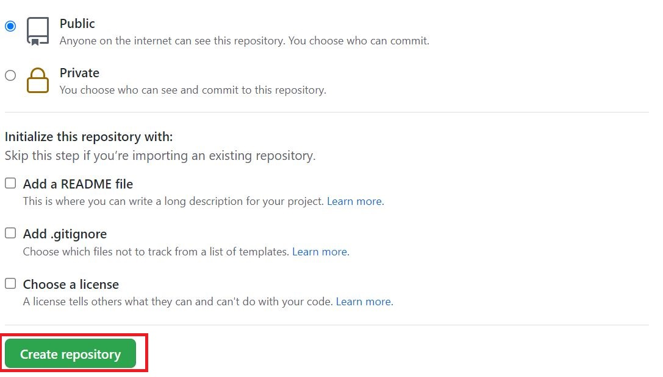
You also have an option to add a README file but it is not mandatory.
Click Create repository to finish creating the repository

Uploading your project to a newly created repository
Click desired repository under repositories
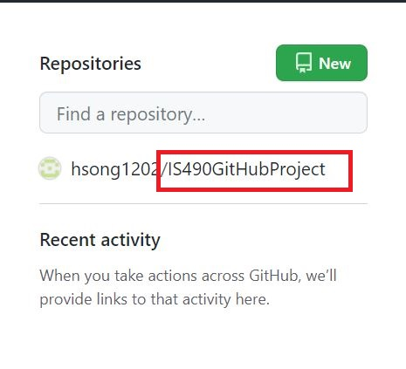
In the following screen, there are many ways to upload your project
One of ways being uploading an existing file in the Quick setup window.
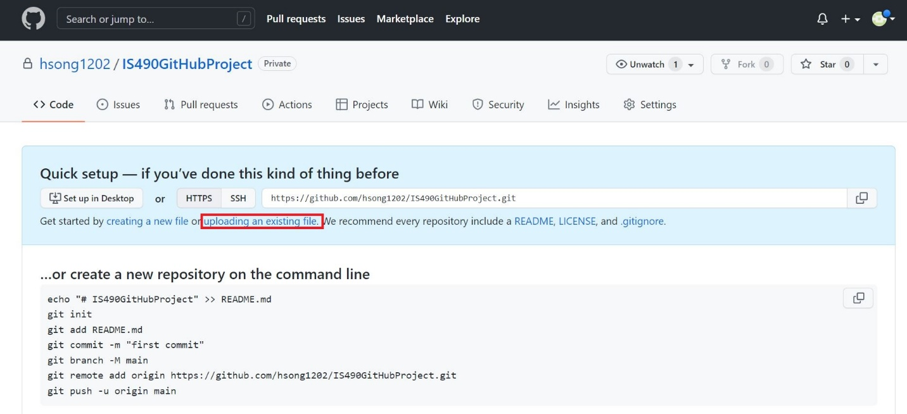
select files to upload by dragging and dropping them or by clicking choose your files and selecting them selectively
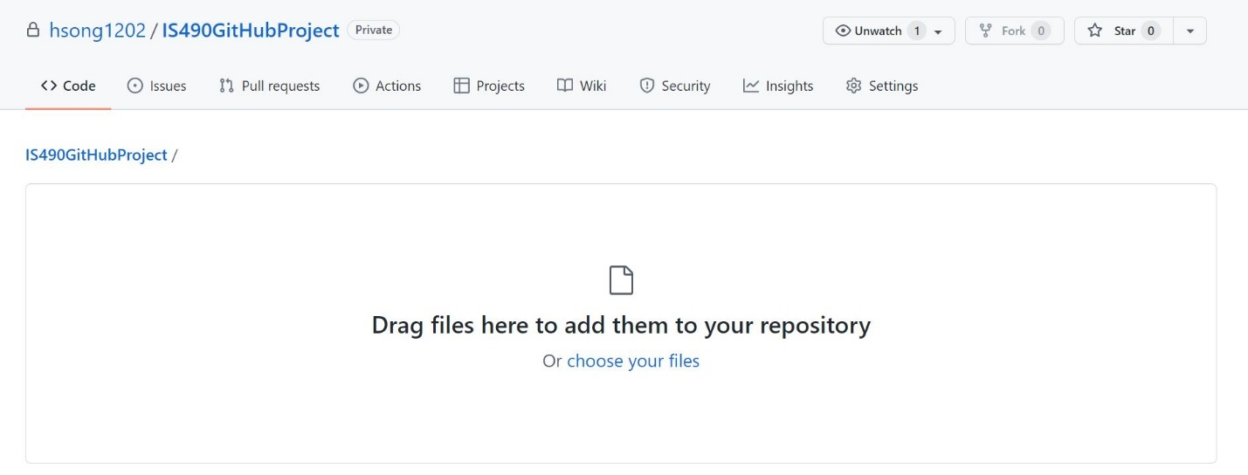
Once you have selected the items to upload, write a summary of the upload and press Commit changes.
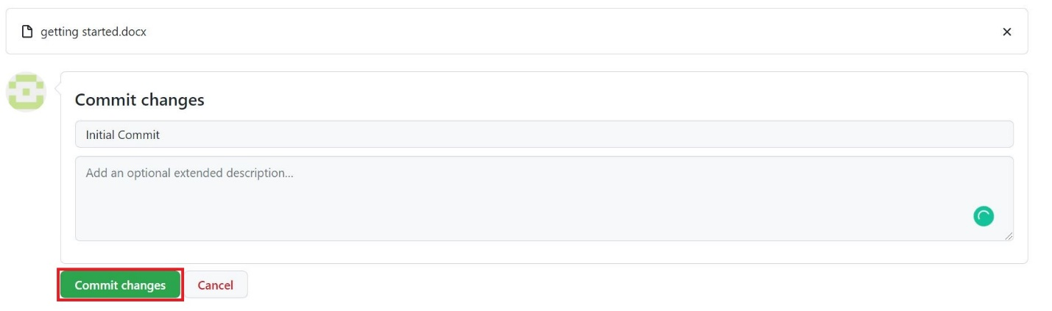

linking your repository to your GitHub Desktop
following steps can be found in documentation below:
https://docs.github.com/en/authentication/keeping-your-account-and-data-secure/about-authentication-to-github
open GitHub Desktop App
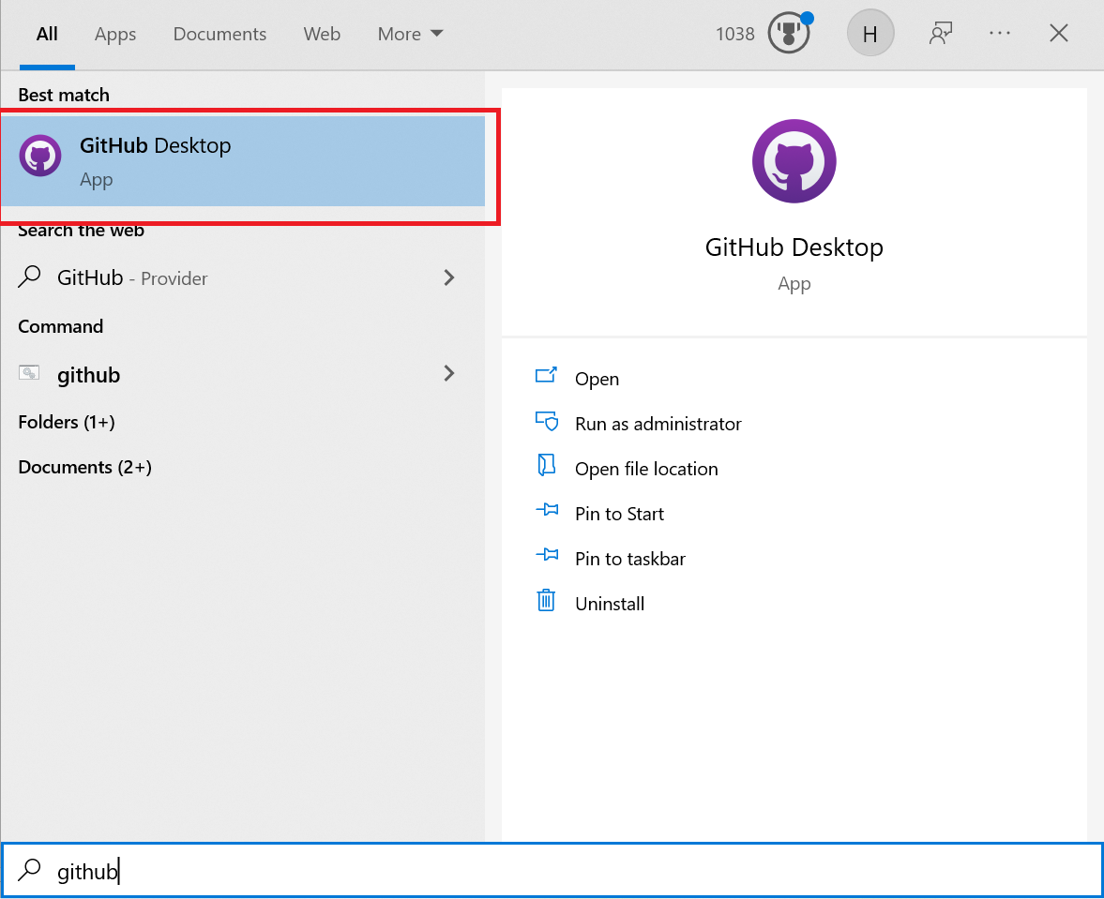
In the
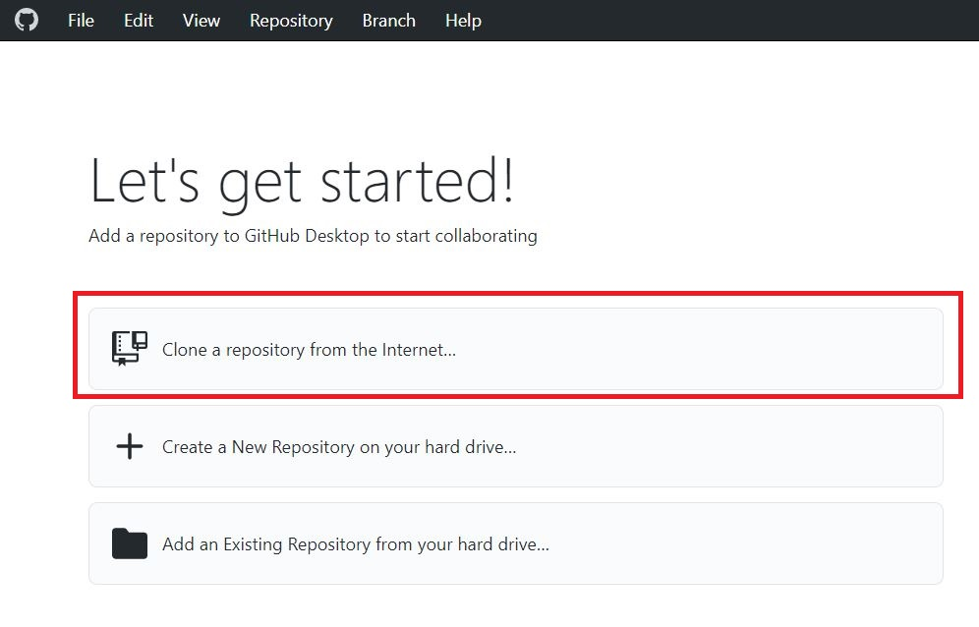
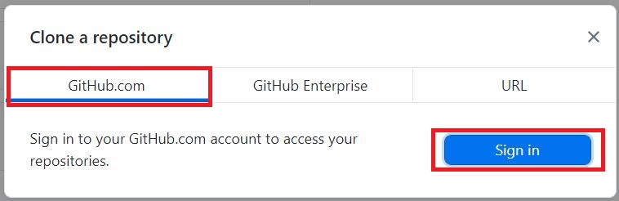
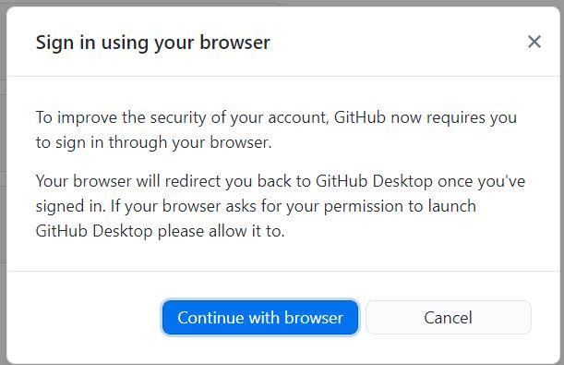
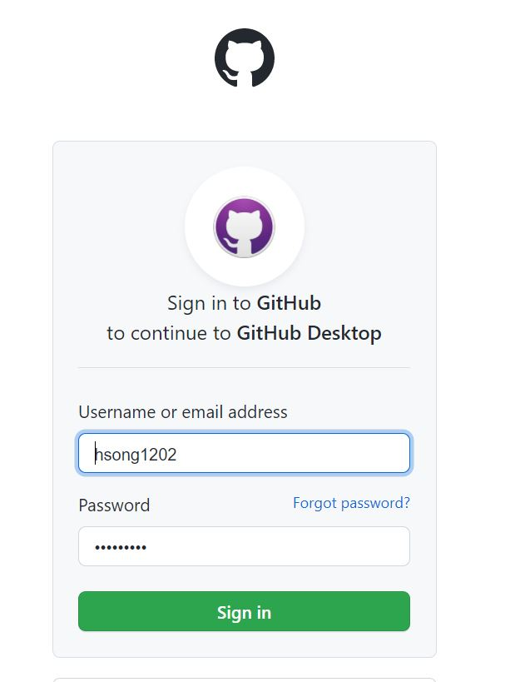
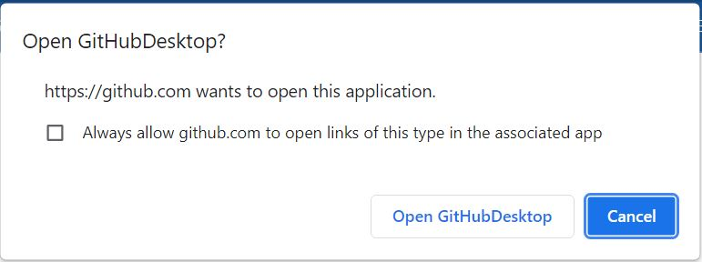
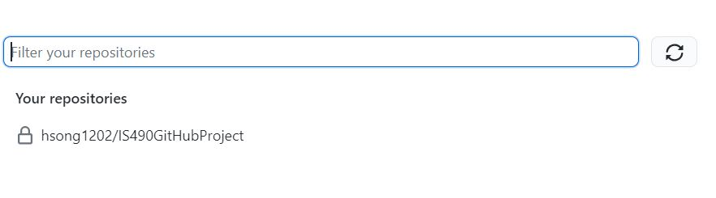
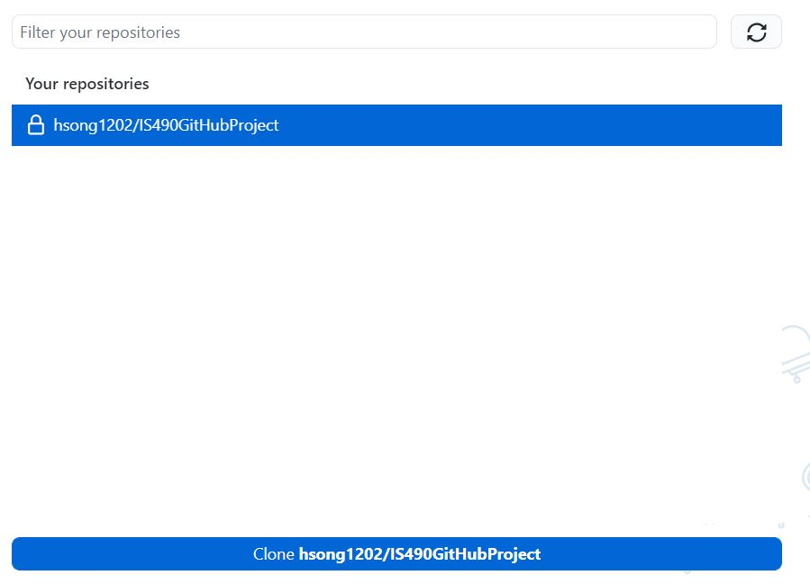
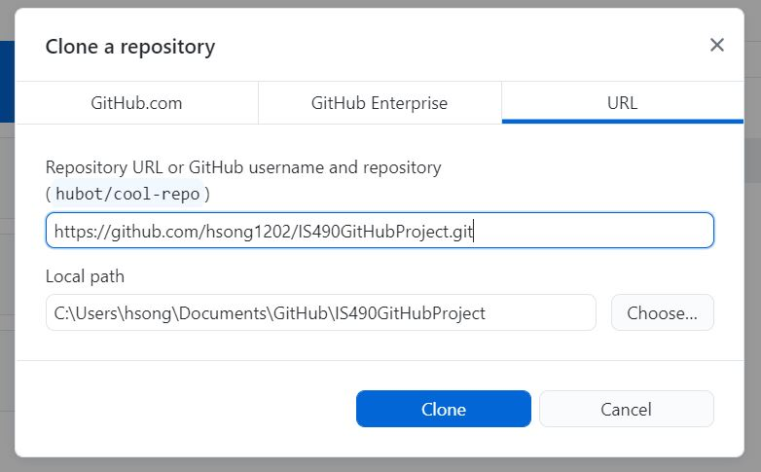

Commit your change
https://docs.github.com/en/get-started/quickstart/create-a-repo
Currently there is no change in the repository directory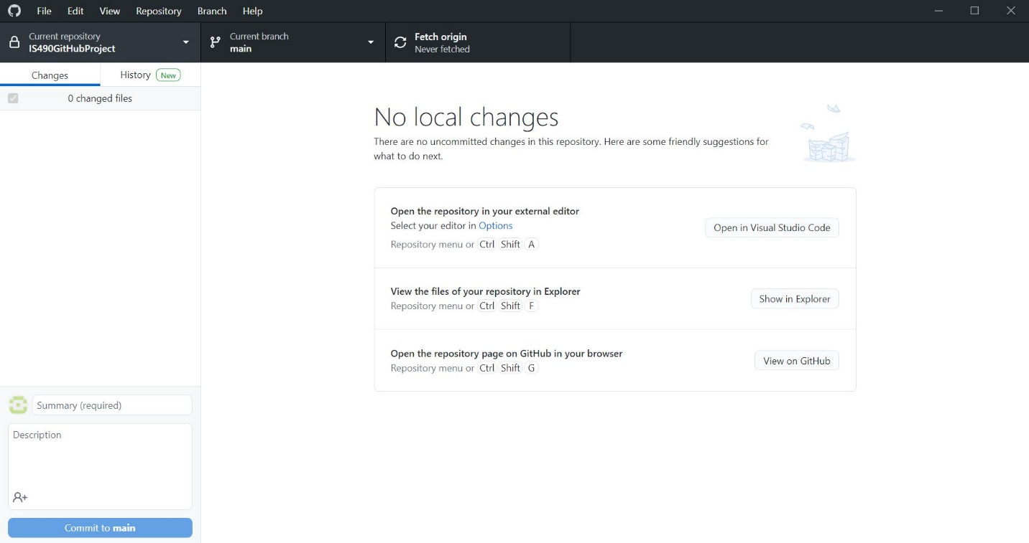
When you create a new file or make an update to the existing file following change appear in the GitHub Desktop App.
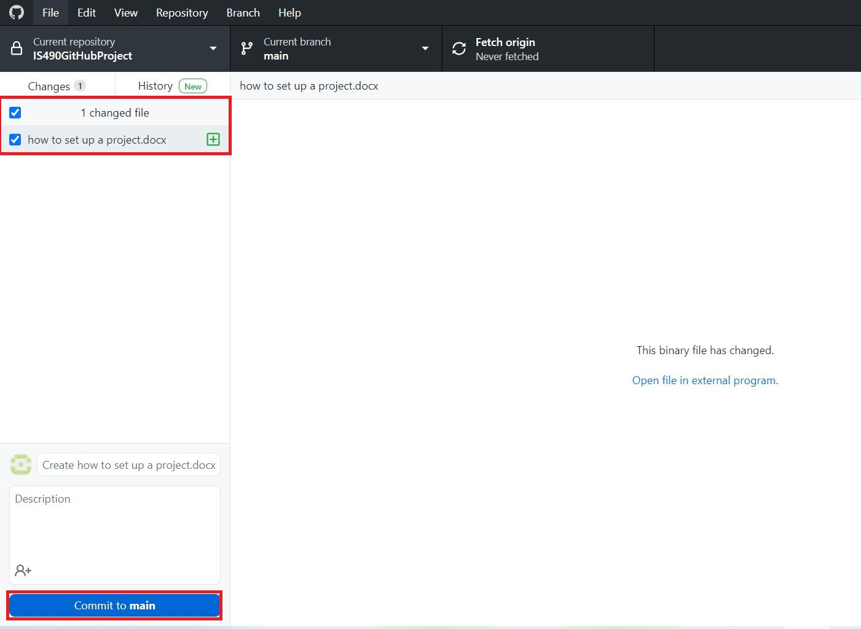
Click Commit to main
Following screen appears
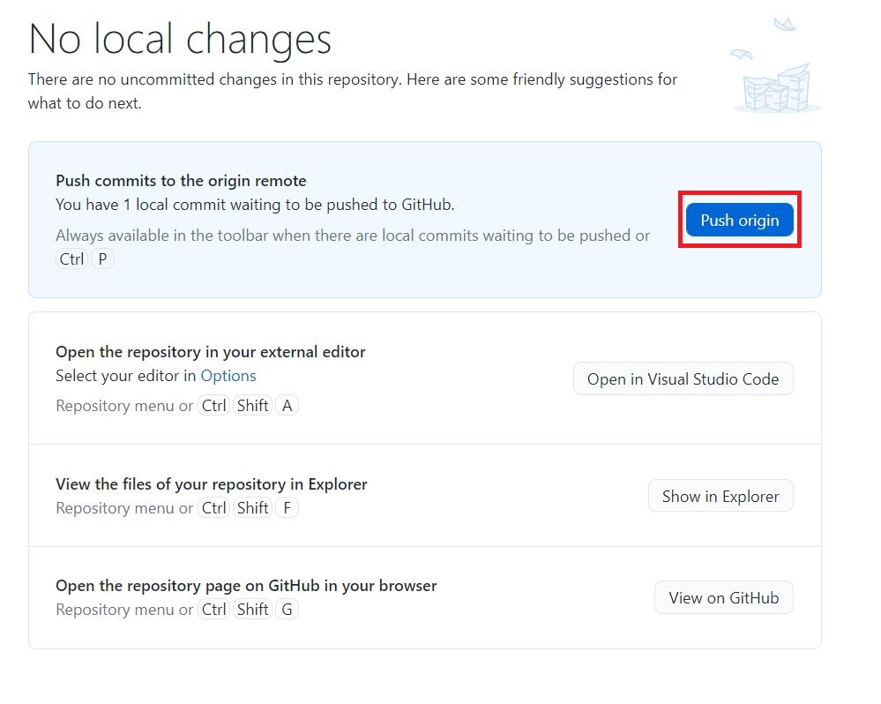
Click Push origin to update your repository
Revisit your repository online
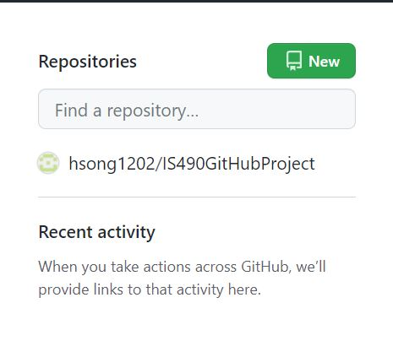
Notice the change in your commit history
